3.



This is the code for parts b, c, and d. The first two lines set the value of theta(x), y, and n. Z is the bottom part of the fraction in the distribution. I decided to calculate it first because it is a constant through the rest of the calculations. Plot then uses these values in a poisson distribution to make the graph. Exp, v, and stddev are the expected value, variance, and standard deviation respectively. I used the plot to plug values into the expected value and variance formula. I then took the square root of variance to get the standard deviation. I then used the stddev and the z value for .95 to calculate the lower and upper bounds of the confidence interval.

e)

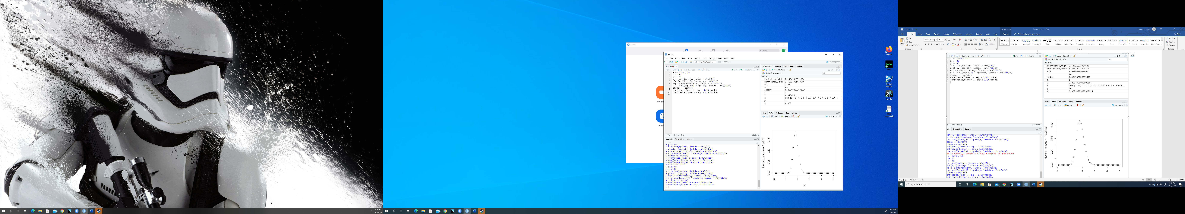

This plot is thinner and taller than the one in the previous plots. This is likely because a higher n causes less variance in the data. The 95% confidence interval is also lower. With a higher n, the value of theta can be more accurately predicted